Software Documentation “Chess”
by Arwid (Arvydas) Bancewicz,
May 17, 2005
OBEA Computer Programming Contest, 2005

Tabled of Contents

Part 1: Graphical User Interface (GUI) Design

Part 2: Exploring the Move Algorithms
Minimax explained
AlfaBeta explained
Move Algorithm Testing

Part 3: Software Development Analysis
Chess Applet
Chess Application

Credits

GUI (Graphical User Interface) Design

The graphical user interface was designed with user friendliness and easiness in mind.
Although there are many panels, the four highlighted panels below are the main panels the user will work with.

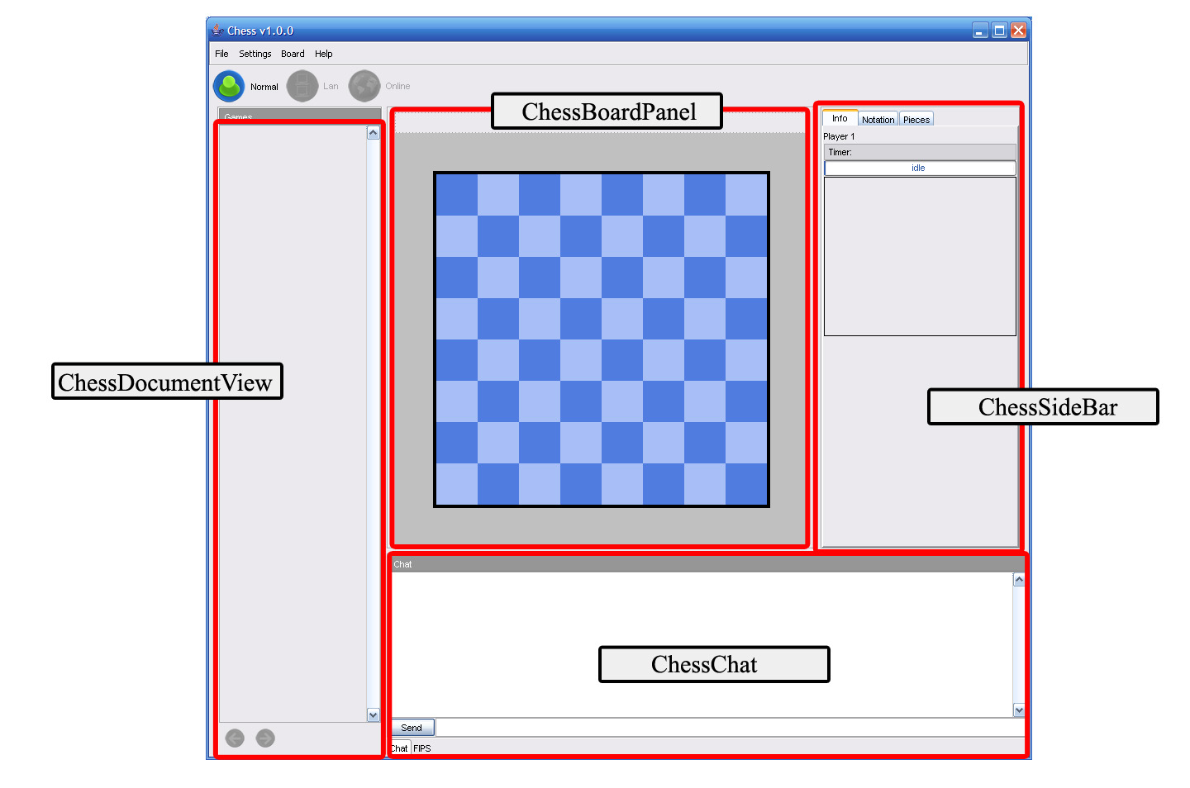

The next pages contain information of each of these panels in the order as shown:

1. The ChessBoardPanel
2. The ChessDocumentView
3. The ChessSideBar

ChessChat is a simple panel so it does not need to be given attention.

The ChessBoardPanel

The ChessBoardPanel holds 3 components: 2 of which are PlayerLabel’s and a ChessBoardMain panel. There is a PlayerLabel for each of the two players, white and black. It displays the player’s name on the left and the player’s timer on the right. The ChessBoardMain represents the current selected game in the ChessDocuments list, which contains a list of all the present games. The board is highly interactive.

You can also access a context menu in the form of a popup by right clicking on the ChessBoardMain. The menu allows for quick access to commands, such as flip the board, zoom in and out, and switch to full mode. All of this is explained in the manual.

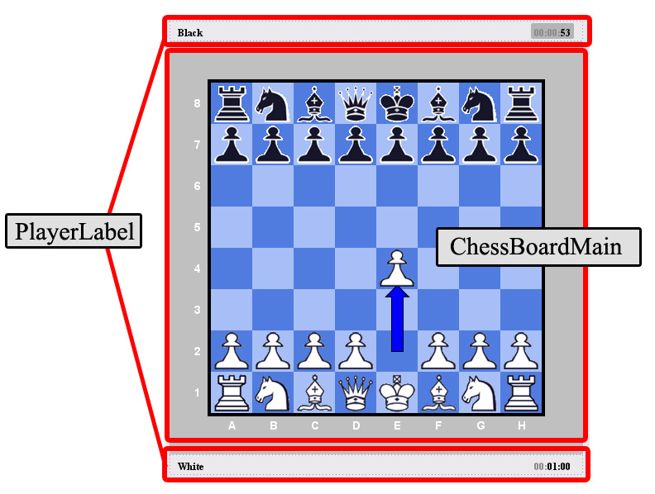

The DocumentView

The DocumentView panel serves as to providing a visual representation in a DocumentThumbnail for each and every game. The DocumentView panel reads the ChessDocuments list which contains a list of all the present games and creates a DocumentView to visually represent it. Selecting a thumbnail will make the game it represents appear in the ChessBoardPanel.

The DocumentThumbnail has a nifty feature; you can minimize and maximize it as you please. The DocumentThumbnail’s can also be minimized or maximized all at once by right clicking on the header labelled “Games” to access a context popup menu.

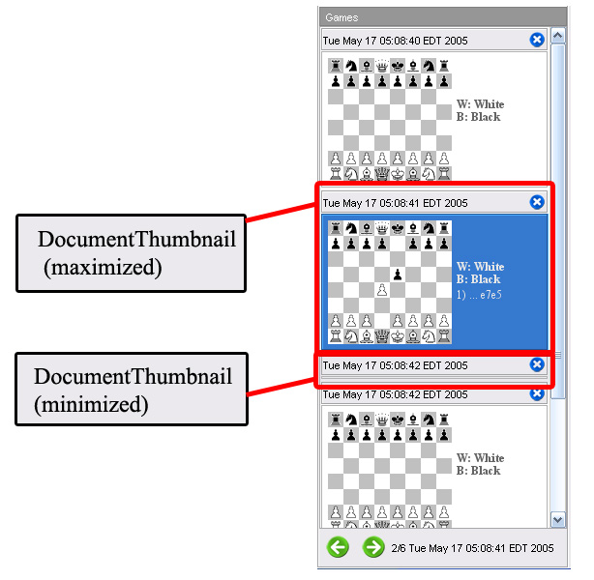

The ChessSideBar

The ChessSideBar contains two tabs: the Notatation tab and the Pieces tab. The Notation tab contains a table having the model ChessTableModel. The ChessTableModel contains a list of moves added by a ChessGame after moving a piece. The moves are then displayed in proper notation in Notation’s table. The Pieces tab shows all the pieces currently on the board or the pieces already captured. It gets the information about the number of pieces from a PieceCounts object. Every Board has a PieceCounts object.
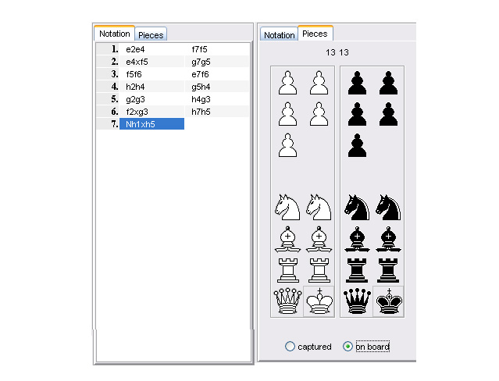

Exploring the Move Algorithms

Unified Modeling Language (UML) Diagram of MoveAlgorithm
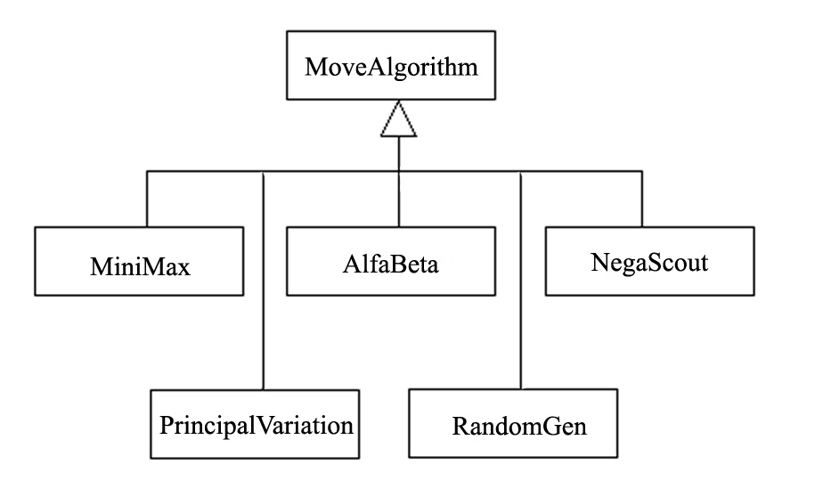

The UML diagram above is a class hierarchy for the MoveAlgorithm class and it’s subclasses.

It is recommended that the reader first consult the following java files before reading on.

These files are located in package chess.core (in folder “core”):
- Board
- Coord
- Move
- Piece

Minimax explained

Minimax is a method in decision theory for minimizing the expected maximum loss.
The minimax algorithm is a recursive algorithm for choosing the next move in a two player game such as chess. A value is associated with each position or state of the game. This value is computed by means of the position evaluation function located in the MoveAlgorithm class:

The value obtained from the estimate function indicates how good it would be for a player to reach that position.

protected int estimate() {
stepcounter++;
int dc = getCost()-est_cost;
int dac = getAttackCost()-est_attackCost;
return dc*10+dac;
}

private int getCost() {
int out = 0;
for(int c=0;c<8;c++)
for(int r=0;r<8;r++)
if(board.b[c][r]!=null)
out+=board.b[c][r].getCost();
return out;
}

Note that board.b encapsulates an 8 by 8 array of Piece objects. The getCost function sums up the cost values for all the pieces currently on the board. A square containing no piece is a value of null in the board.b array. The cost for a piece is found in the Constants class:

int[] cost = {1,5,5,10,40,100};

The pawn is given the value of 1, 5 for the rook, 5 for the knight, 10 for the bishop, 40 for the queen, and 100 for the king. Notice that the values increase for the more valuable pieces. Also, if we look at the getCost method in the Piece class:

public int getCost() {
return (white?1:-1)*cost[type];
}

The getCost function for each piece returns a positive value if the piece is white or a negative value if the piece is not white, but black. Thus, summing the cost values for all pieces in the estimate function returns a positive value if white is in favour or negative if black is in favour.

The getAttackCost function:

private int getAttackCost() {
int out = 0;
for(byte c=0;c<8;c++)
for(byte r=0;r<8;r++)
if(board.b[c][r]!=null) {
Vector v = getRealAttacks(new Coord(c,r));
if(v!=null)
for(int k=0;k<v.size();k++) {
Move m = (Move)v.elementAt(k);
out += board.b[m.x2][m.y2].getCost();
}
}
return -out;
}

The getAttackCost function is similar to getCost with the exception that it sums up the cost values for all the pieces that could be captured/killed. The function getAttackCost also returns the negative of the value because black pieces, which will return negative values, are good for the white player since white could capture these pieces. Thus the value returned is again positive if white is in favor or negative if black is in favor.

Now, going back to the return value of the estimate function:

return dc*10+dac;

This expression in words: the cost x 10 + the attack cost

Now that we know how a board position is evaluated, it makes sense that for the computer opponent to be effective, the algorithm will have to evaluate several board positions and even the board positions several moves ahead. The number of moves ahead is called the “look-ahead” or “ply”.

The minimax algorithm, as any algorithm, can be thought of as exploring the nodes of a game tree. The number of nodes to be explored usually increases exponentially with the number of plies. It is less than exponential if evaluating forced moves. For example, a white king checked by a black piece does not have many options but to get itself out of check.

A game tree, as mentioned earlier, is a tree of nodes. The example below is a game tree of the game tic-tac-toe. Notice the game tree contains all the possible nodes (positions in a game). It contains the number of possible different ways the game can be played. The tic-tac-toe game tree is a good example of a game tree since it has a very few number of possible games; 26 different nodes and 830 possible games to be exact. In contrast, the complete chess game tree has an immense number of nodes; not to even imagine the number of possible games.
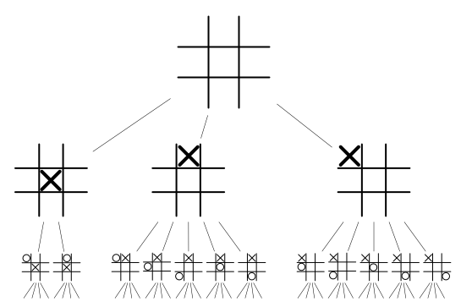

Lets look at a chess situation where the white player has only three choices for moves. The white makes a move and now the black player has three choices for moves. This is illustrated in the example below:

 | Black chooses B1 | Black chooses B2 | Black chooses B3
White chooses move A1 | +7 | -2 | +2
White chooses move A2 | -1 | 1 | +4
White chooses move A3 | 0 | -6 | +1

The values of the cells in-between are the board evaluation. For example, if white chooses A1 and black chooses B2 then A1 pays 2 to black (white loses). The simple minimax choice for white is A2 since the worst possible result is then having to pay 1. The none minimax choice for white is A3 since the worst possible result is to pay 6. This is basically how the minimax algorithm works.

AlfaBeta explained

The alfa-beta technique is called alpha-beta pruning. The technique reduces the number of nodes evaluated by the minimax algorithm. It prunes or cuts out parts of the search tree that are soo good for one player that the opponent will never allow them to be reached. Searching these nodes is obviously not necessary.

In sort, the alpha-beta pruning technique produces the same result as what minimax would, but without searching those unnecessary nodes. This vastly increases the actual time to search the search tree.

The algorithm maintains two values, alpha and beta, which represent the minimum score that the maximizing player is assured of and the maximum score that the minimizing player is assured of respectively. Initially alpha is minus infinity and beta is plus infinity.
The beta value will eventually become less than alpha, which means that the current position cannot be the result of best play by both players and hence does not need to be explored furthur. Thus this part of the tree is pruned/cut off.

The pseudocode of the alpha-beta (or alfa-beta) algorithm is given below. It is of that used by the AlfaBeta class.

NOTE: “depth” has the same meaning as “ply”

evaluate (depth, alpha, beta)
if the depth is 0
return the value 0
get all the legal moves for this player
if the player is the minimizing node
if this player has some moves
for each of its moves
beta = min (beta, evaluate (depth-1, alpha, beta))
if beta <= alpha
return alpha
return beta
if the player is the maximizing node
if this player has some moves
for each of its moves
alpha = max (alpha, evaluate (depth-1, alpha, beta))
if beta <= alpha
return beta
return beta

The other algorithms, Principal Variation and NegaScout, are very similar to alfa-beta while the RandomGen algorithm simply generates a random but legal move.
You can run a test of these algorithms by compiling and running Tester.java found in the package chess.algorithms (the algorithms folder). Follow the instructions in the file to see the algorithms in action.

A sample output is shown below.

* Notice the large number of nodes and the relation between # of nodes and time. This is expected since a larger search tree, having more nodes than a smaller search tree, will take more time to search.

Move Algorithm Testing: Sample Output

White replies with AlfaBeta
reply => Bg1f3
time = seconds: 1 milliseconds: 625
depth # of nodes evaluation
5 13065 0

Black replies with AlfaBeta
reply => b7b6
time = seconds: 2 milliseconds: 187
depth # of nodes evaluation
5 29989 0

White replies with NegaScout
reply => Bb1a3
time = seconds: 1 milliseconds: 375
depth # of nodes evaluation
5 11798 0

Black replies with NegaScout
reply => c7c5
time = seconds: 1 milliseconds: 704
depth # of nodes evaluation
5 26079 0

White replies with PrincipalVariation
reply => Bb1c3
time = seconds: 1 milliseconds: 469
depth # of nodes evaluation
5 11893 0

Black replies with PrincipalVariation
reply => c7c5
time = seconds: 2 milliseconds: 578
depth # of nodes evaluation
5 31069 0

Here is data table containing the results of various tests made with these move algorithms. Notice that the Minimax replies and those of AlfaBeta are identical but the number of nodes are higher for Minimax and the time taken is lower for AlfaBeta. This is clearly seen in the highlighted rows below, although generating identical moves, Minimax goes through 19,7281 nodes white AlfaBeta goes through 998 nodes. This is reflected in the amount of time taken, which is a difference of approximately 16 seconds. This gives us a clear understanding why AlfaBeta is a much favoured technique over Minimax. You can also notice that the other two algorithms produce very similar results
in the number of nodes and time.

Move Algorithm Testing: Data

Algorithm | Depth | White | Reply  (Move) | Number of nodes | Time (s)
Minimax | 1 | true | Bb1a3 | 20 | 0.150
Minimax | 1 | false | h7h5 | 20 | 0.000
Minimax | 2 | true | d2d4 | 400 | 0.790
Minimax | 2 | false | c7c6 | 400 | 0.310
Minimax | 3 | true | d2d3 | 8902 | 0.687
Minimax | 3 | false | c7c5 | 8902 | 0.610
Minimax | 4 | true | f2f4 | 197281 | 17.125
Minimax | 4 | false | g7g5 | 197281 | 16.703
AlfaBeta | 1 | true | Bb1a3 | 21 | 0.031
AlfaBeta | 1 | false | h7h5 | 21 | 0.031
AlfaBeta | 2 | true | d2d4 | 40 | 0.047
AlfaBeta | 2 | false | c7c6 | 40 | 0.031
AlfaBeta | 3 | true | d2d3 | 467 | 0.078
AlfaBeta | 3 | false | c7c5 | 522 | 0.063
AlfaBeta | 4 | true | f2f4 | 986 | 0.422
AlfaBeta | 4 | false | g7g5 | 998 | 0.312
AlfaBeta | 5 | true | c2c4 | 14710 | 1.891
AlfaBeta | 5 | false | g7g6 | 15714 | 2.016
AlfaBeta | 6 | true | f2f3 | 159048 | 37.843
AlfaBeta | 6 | false | d7d6 | 45304 | 12.610
NegaScout | 1 | true | Bb1c3 | 20 | 0.031
NegaScout | 1 | false | b7b5 | 20 | 0.000
NegaScout | 2 | true | f2f3 | 39 | 0.032
NegaScout | 2 | false | d7d6 | 39 | 0.015
NegaScout | 3 | true | Bg1f3 | 466 | 0.062
NegaScout | 3 | false | Bg8h6 | 466 | 0.062
NegaScout | 4 | true | a2a4 | 929 | 0.297
NegaScout | 4 | false | g7g5 | 995 | 0.281
NegaScout | 5 | true | c2c4 | 11858 | 1.500
NegaScout | 5 | false | c7c5 | 15360 | 2.109
NegaScout | 6 | true | b2b3 | 142302 | 27.031
NegaScout | 6 | false | f7f5 | 29571 | 9.016
PrincipalVariation | 1 | true | g2g4 | 20 | 0.015
PrincipalVariation | 1 | false | d7d5 | 20 | 0.000
PrincipalVariation | 2 | true | a2a4 | 39 | 0.015
PrincipalVariation | 2 | false | Bg8h6 | 39 | 0.031
PrincipalVariation | 3 | true | Bb1a3 | 466 | 0.062
PrincipalVariation | 3 | false | b7b5 | 466 | 0.063
PrincipalVariation | 4 | true | e2e4 | 932 | 0.328
PrincipalVariation | 4 | false | Bg8h6 | 995 | 0.297
PrincipalVariation | 5 | true | g2g3 | 11757 | 1.406
PrincipalVariation | 5 | false | e7e6 | 15976 | 2.203
PrincipalVariation | 6 | true | h2h4 | 143049 | 26.609
PrincipalVariation | 6 | false | Bb8c6 | 29637 | 9.422

Software Development Analysis

Software development duration:

Chess Applet: Oct 22 2004 – Jan 21 2005 approx. 3 months
Chess Application: Nov 15 2004 – May 16 2005 approx. 6 months

This Software Development Analysis contains both an analysis for the Chess Applet development and an analysis for the Chess Application development.

This development analysis is meant to give a broad understanding of the type of files involved in each and the scale of each program. The data for each program type was obtained in the date specified below each program heading in the next pages. The pages are ordered as follows:

- Software Development Analysis: Chess Applet
- Software Development Analysis: Chess Application

Software Development Analysis: Chess Applet

NOTE: the data tables were accumulated with the data of Jan 23 2004

File Count
package | # of .java files
ICS4M1_ChessProject | 17
total | 17

File Information
.java file | Type | Extends | Implements
Chess | class | Applet
ChessBoard | class | JPanel | Constants, MouseListener,  MouseMotionListener, ActionListener, Runnable
ChessBottom | class | Applet | Runnable
ChessConsole | class |  | Constants
ChessGame | class |  | Constants
ChessMinimax | class
ChessPlayer | class
ChessSideBar | class | JPanel | ActionListener, Runnable
ChessTools | class |  | Constants
Constants | interface
Coord | class |  | Constants
ImageManipulator | class |  | RGBImageFilter
ListModel | class |  | AbstractListModel
Move | class |  | Constants
Piece | class |  | Constants
ThreadApp | class | Thread | Constants
timer | class

Status Reports

Date | Time Spent (approximates) | Brief
Leading up to Fri. Oct. 22 2004 | ? | - ideas, discussion
Fri. Oct. 22 2004 | > 10 hrs | - began coding structure
Sat. Oct. 23 2004 | - 4 hrs - | ---
Sun. Oct. 24 2004 | - ? - | ChessApplet.java v0.1 complete
Sat. Nov. 06 2004 | - 2 hrs - | - implemented player turns, fixed bugs – board now resizes + double click error
Mon. Nov. 08 2004 | - 3 hrs - | - generating legal moves + fixed bugs. Big change: the user’s moves that were defined in the ‘mouseReleased’ method are now defined in a new method – used by both the user and will be by the AI which is not yet implemented.  Next step for AI: calculate for each piece whether it’s protected, if so, by how many pieces – and is the piece targeted by enemy pieces, if so – how many
Thurs. Nov. 11 2004 | - class time - | - made space on the side for game info
Fri. Nov. 12 2004 | - 5 hours - | - pixel graphics (color changes) + display inactive pieces on the side + fixed bugs and began 3d pixelling
Sat. Nov. 13 2004 | - 2 hours - | - fixed bug, although new problem not noticed before: while dragging a piece and then with a second mouse click on a different piece the dragging piece disappears  - spacing for the board
Tue. Nov. 24 2004 | - 30 min - | - problem – when releasing a piece on the edges of the board, the piece moves but also reappears in it’s original location  - fixed – although a piece can not be dropped on the furthest left edge now

Date | Time Spent (approximates) | Brief
Wed. Nov. 25 2004 | - class time - | TODO: 1-Allow moves by not only piece dragging, but also by clicking on the original square and then the square to move to.  2- Once a piece is clicked on, show all the possible moves for the piece  3- Animate darkening of the board with bright center box with changeable settings.  4- Computer – don’t take the AI learning approach, instead, give it a set of rules for prioritizing some locations over others  5. Create clickable tab regions to display different game info  6- Log piece movement history in one of the tabs.
Wed. Dec. 01 2004 | - 3 hrs - | - a “dots” game AI
Sat. Dec. 04 2004 | - 5 hrs - | - split the code into classes (now ChessConsole holds all the piece information and settings)  - organize the code  - the last move is indicated on the chess board (highlighted)
Sun. Dec. 05 2004 | - ? - | - tabs are switchable and working  - the board’s width and height stay proportional when the frame is resized
Mon. Dec. 06 2004 | - 5 hrs - | - new pieces + new board
Thurs. Dec. 30 2004 | - 2 hrs - | - split the code furthur into classes and objects + new panel layout  - the console is abstract

Date | Time Spent (approximates) | Brief
Dec. 21 2004 –  Fri. Jan 21 2005 | - ? - | - reformatted all classes.  - AI complete  - modifying different opponent strengths  - new piece images + sound  - new layout (now 3 panels)  - board and sideboard now split up  - move notation reformated  - sliding pieces now during game play  - optional features such as show legal moves with arrows  - main menu, settings menu, new game menu
Sun. Jan. 23 2005 | - ? - | ChessApplet v1.0.0 complete

Software Development Analysis: Chess Application

NOTE: the data tables were accumulated with the data of May 16 2005

File Count
package | # of .java files
chess | 1
chess.algorithms | 7
chess.core | 24
chess.gui | 1
chess.gui.board | 6
chess.gui.lookAndFeel | 11
chess.gui.panels | 7
chess.gui.window | 11
chess.media | 3
chess.network | 8
chess.online | 4
chess.properties | 10
total | 93

File Information Ascending With Date Created
.java file | Package | Type | Extends | Implements | Date Created
ChessGame | chess.core | class |  | Constants, Serializable | Nov 15 2004
ImageManipulator | chess.core | class |  | RGBImageFilter | Nov 20 2004
ChessBoard | chess.gui.board | class | JPanel | Constants | Dec 02 2004
Constants | chess.core | interface |  |  | Dec 02 2004
Coord | chess.core | class |  | Constants, Serializable | Dec 10 2004
Move | chess.core | class |  | Constants, Serializable | Dec 11 2004
ChessListModel | chess.core | class | AbstractListModel | Serializable | Dec 16 2004
Piece | chess.core | class |  | Constants, Serializable | Dec 24 2004

.java file | Package | Type | Extends | Implements | Date Created
ChessChat | chess.network |  |  | ActionListener | Feb 10  2005
ChessClient | chess.network |  | NetworkEnd |  | Feb 10  2005
ChessNetPlay | chess.network |  |  |  | Feb 10  2005
ChessServer | chess.network |  | NetworkEnd |  | Feb 10  2005
MsgRedirector | chess.network |  |  | Runnable | Feb 10  2005
NetworkEnd | chess.network |  |  |  | Feb 10  2005
TestClient | chess.network |  | JFrame |  | Feb 10  2005
TestServer | chess.network |  | JFrame | ActionListener | Feb 10  2005
ChessComponent | chess.gui.panels | class | JPanel |  | Feb 22  2005
Chess | chess.gui | class | JFrame | ActionListener | Mar 02 2005
ChessPreferences | chess.properties |  |  |  | Mar 05 2005
PreferencesDialog | chess.gui.window | class | JDialog |  | Mar 16 2005
MoveAlgorithm | chess.algorithms | class |  | Constants | Mar 16 2005
AlfaBeta | chess.algorithms | class | MoveAlgorithm |  | Mar 16 2005
NegaScout | chess.algorithms | class | MoveAlgorithm |  | Mar 16 2005
PrincipalVaration | chess.algorithms | class | MoveAlgorithm |  | Mar 16  2005
ChessPreferences | chess.properties | class |  |  | Mar 16 2005
ChessColors | chess.properties | interface |  |  | Mar 20 2005
ChessBoardMain | chess.gui.board | class | ChessBoard |  | Mar 20 2005

.java file | Package | Type | Extends | Implements | Date Created
ChessBoardSmallView | chess.gui.board | class | ChessBoard |  | Mar 20 2005
ChessBoardVirtual | chess.gui.board | class |  | Constants,  MouseListener | Mar 20 2005
AboutDialog | chess.gui.window | class | JDialog | ActionListener | Mar 20 2005
ChessSetDialog | chess.gui.window | class | JDialog | ActionListener | Mar 20 2005
ExitDialog | chess.gui.window | class | JDialog | ActionListener | Mar 20 2005
ChessDocuments | chess.core | class | AbstractListModel |  | Mar 21 2005
ChessDocumentView | chess.gui.panels | class | JPanel |  | Mar 21 2005
SplashScreen | chess.gui.window | class | JDialog |  | Mar 23  2005
PeerConnectDialog | chess.gui.window | class | JDialog |  | Mar 23  2005
Parameters | chess.properties | class |  |  | Mar 24 2005
GameParameters | chess.properties | class | Parameters | Constants, Serializable | Mar 24 2005
PlayerParameters | chess.properties | class | Parameters | Serializable | Mar 24 2005
State | chess.properties | class |  | Serializable | Mar 24 2005
FlatButton | chess.core | class | JPanel |  | Mar 25 2005
ComponentList | chess.core | class | JList |  | Mar 27 2005
DocumentThumbnail | chess.core | class | JPanel |  | Mar 27 2005
ChessBoardSetup | chess.gui.board | class | ChessBoard |  | Mar 27 2005
PiecesPanel | chess.gui.panels | class | JPanel | Constants, ActionListener | Mar 27 2005
ChessSetupDialog | chess.gui.window | class | JDialog | ActionListener | Mar 27 2005

.java file | Package | Type | Extends | Implements | Date Created
BoardMedia | chess.media | class |  | Constants | Mar 27 2005
MyLookAndFeel | chess.gui.lookAndFeel | class | MetalLookAndFeel |  | Mar 27 2005
BoardParameters | chess.properties | class | Parameters | Constants | Mar 28 2005
ResumeStateDialog | chess.gui.window | class | JPanel | ActionListener | Mar 30 2005
ButtonUI | chess.gui.lookAndFeel | class | BasicButtonUI |  | Mar 30 2005
ChessFileFilter | chess.core | class | FileFilter |  | Mar 31 2005
ScrollBarUI | chess.gui.lookAndFeel | class | MetalScrollBarUI |  | Apr 01  2005
ToggleButtonUI | chess.gui.lookAndFeel | class | MetalToggleButtonUI |  | Apr 01  2005
DefaultTheme | chess.gui.lookAndFeel | class | DefaultMetalTheme |  | Apr 02  2005
FastGradientPaint | chess.gui.lookAndFeel | class |  | PaintContext | Apr 02  2005
GrayTheme | chess.gui.lookAndFeel | class | DefaultMetalTheme |  | Apr 02  2005
MenuBarUI | chess.gui.lookAndFeel | class | BasicMenuBarUI |  | Apr 02  2005
TabbedPaneUI | chess.gui.lookAndFeel | class | BasicTabbedPaneUI |  | Apr 02  2005
ToolBarUI | chess.gui.lookAndFeel | class | BasicToolBarUI |  | Apr 02  2005
MiniMax | chess.algorithms | class | MoveAlgorithm |  | Apr 02  2005
RandomGen | chess.algorithms | class | MoveAlgorithm |  | Apr 02  2005
Tester | chess.algorithms | class |  |  | Apr 02  2005
SpringUtilities | chess.gui.window | class |  |  | Apr 02  2005
JTableCellRenderer | chess.core | class | TableCellRenderer |  | Apr 03  2005

.java file | Package | Type | Extends | Implements | Date Created
CustomCellRenderer | chess.core | class | JLabel | TableCellRenderer | Apr 03  2005
ChessTableModel | chess.core | class | AbstractTableModel |  | Apr 03  2005
HelloNet | chess.online | class | JFrame | ActionListener, Runnable | Apr 09  2005
FICSProtocol | chess.online | class | JFrame | Runnable | Apr 14  2005
FICSProtocolHandler | chess.online | class | ICSProtocolHandler |  | Apr 14  2005
ICSProtocolHandler | chess.online | class |  | Runnable | Apr 14  2005
ClockPanel | chess.gui.panels | class | JPanel |  | Apr 19  2005
VirtualClock | chess.core | class |  | Constants, Serializable | Apr 19  2005
VisualClock | chess.core | class | JApplet |  | Apr 19  2005
PlayerLabel | chess.core | class | JPanel |  | Apr 22  2005
PGN | chess.core | class |  |  | Apr 27  2005
ChessFile | chess.core | class |  |  | May 03 2005
Main | chess | class |  |  | May 04  2005
ErrorMessage | chess.gui.window | class | JDialog |  | May 04  2005
InfoLabel | chess.core | class | JLabel |  | May 05  2005
ImageUtilities | chess.media | class |  |  | May 08  2005
Surface | chess.media | class |  |  | May 08  2005
Board | chess.core | class |  | Constants | May 10 2005
ChessBoardSample | chess.gui.board | class | JPanel | Constants | May 10 2005

Computer | chess.core | class | Thread |  | May 13 2005
PieceCounts | chess.core | class |  | Constants | May 13 2005
GameDetailsDialog | chess.gui.window | class | JDialog |  | May 15 2005
ChessSmallMode | chess.gui.panels | class |  |  | May 15 2005
Utilities | chess.properties | class |  |  | May 15 2005

.java file | Package | Type | Extends | Implements | Date Created

Credits

The Chess project was created by Arvydas Bancewicz, including the contents described below.

All of the images, other then, the piece images were created by the author. The original images can be found in this software package in the photoshop document (.psd) file format. These images are in their raw form and can be opened via Adobe Photoshop.

All end-user and technical documentation was created by the author, with the author’s wording.

